

Joylan E. Panungcat

BSIT 4A

IT 411-System Integration and Architecture

1. **You are an IT advisor to your team that is studying a sales system. The proposed system will provide more information and faster updates. The sales promotion policies are written below:**

a. Create a Structured English that describes the process.

IF the customer’s ordered more than P 1,000.00

THEN Discount is 10%

ELSE IF customer ordered less than P1,000.00

THEN bonus coupon is P300.00

ELSE Bonus coupon is P100.00

1. Draw a decision tree that describes the process.

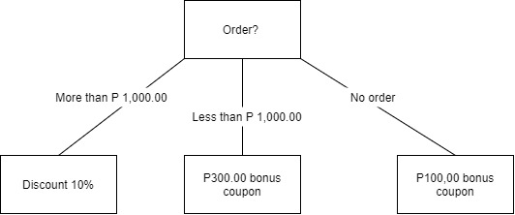

1. **Consider a typical ATM process wherein you can check your balance and withdraw funds. Consider also that you need to enter the PIN number after inserting your ATM card, the transaction record will also be printed after withdrawing funds.**
2. Create a general use-case diagram for the ATM processes.

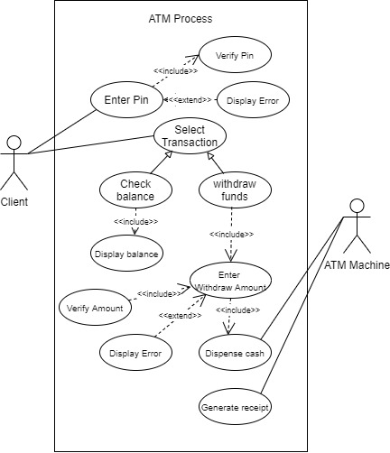

1. Create a sequence diagram or state-transition diagram for the ATM processes.

